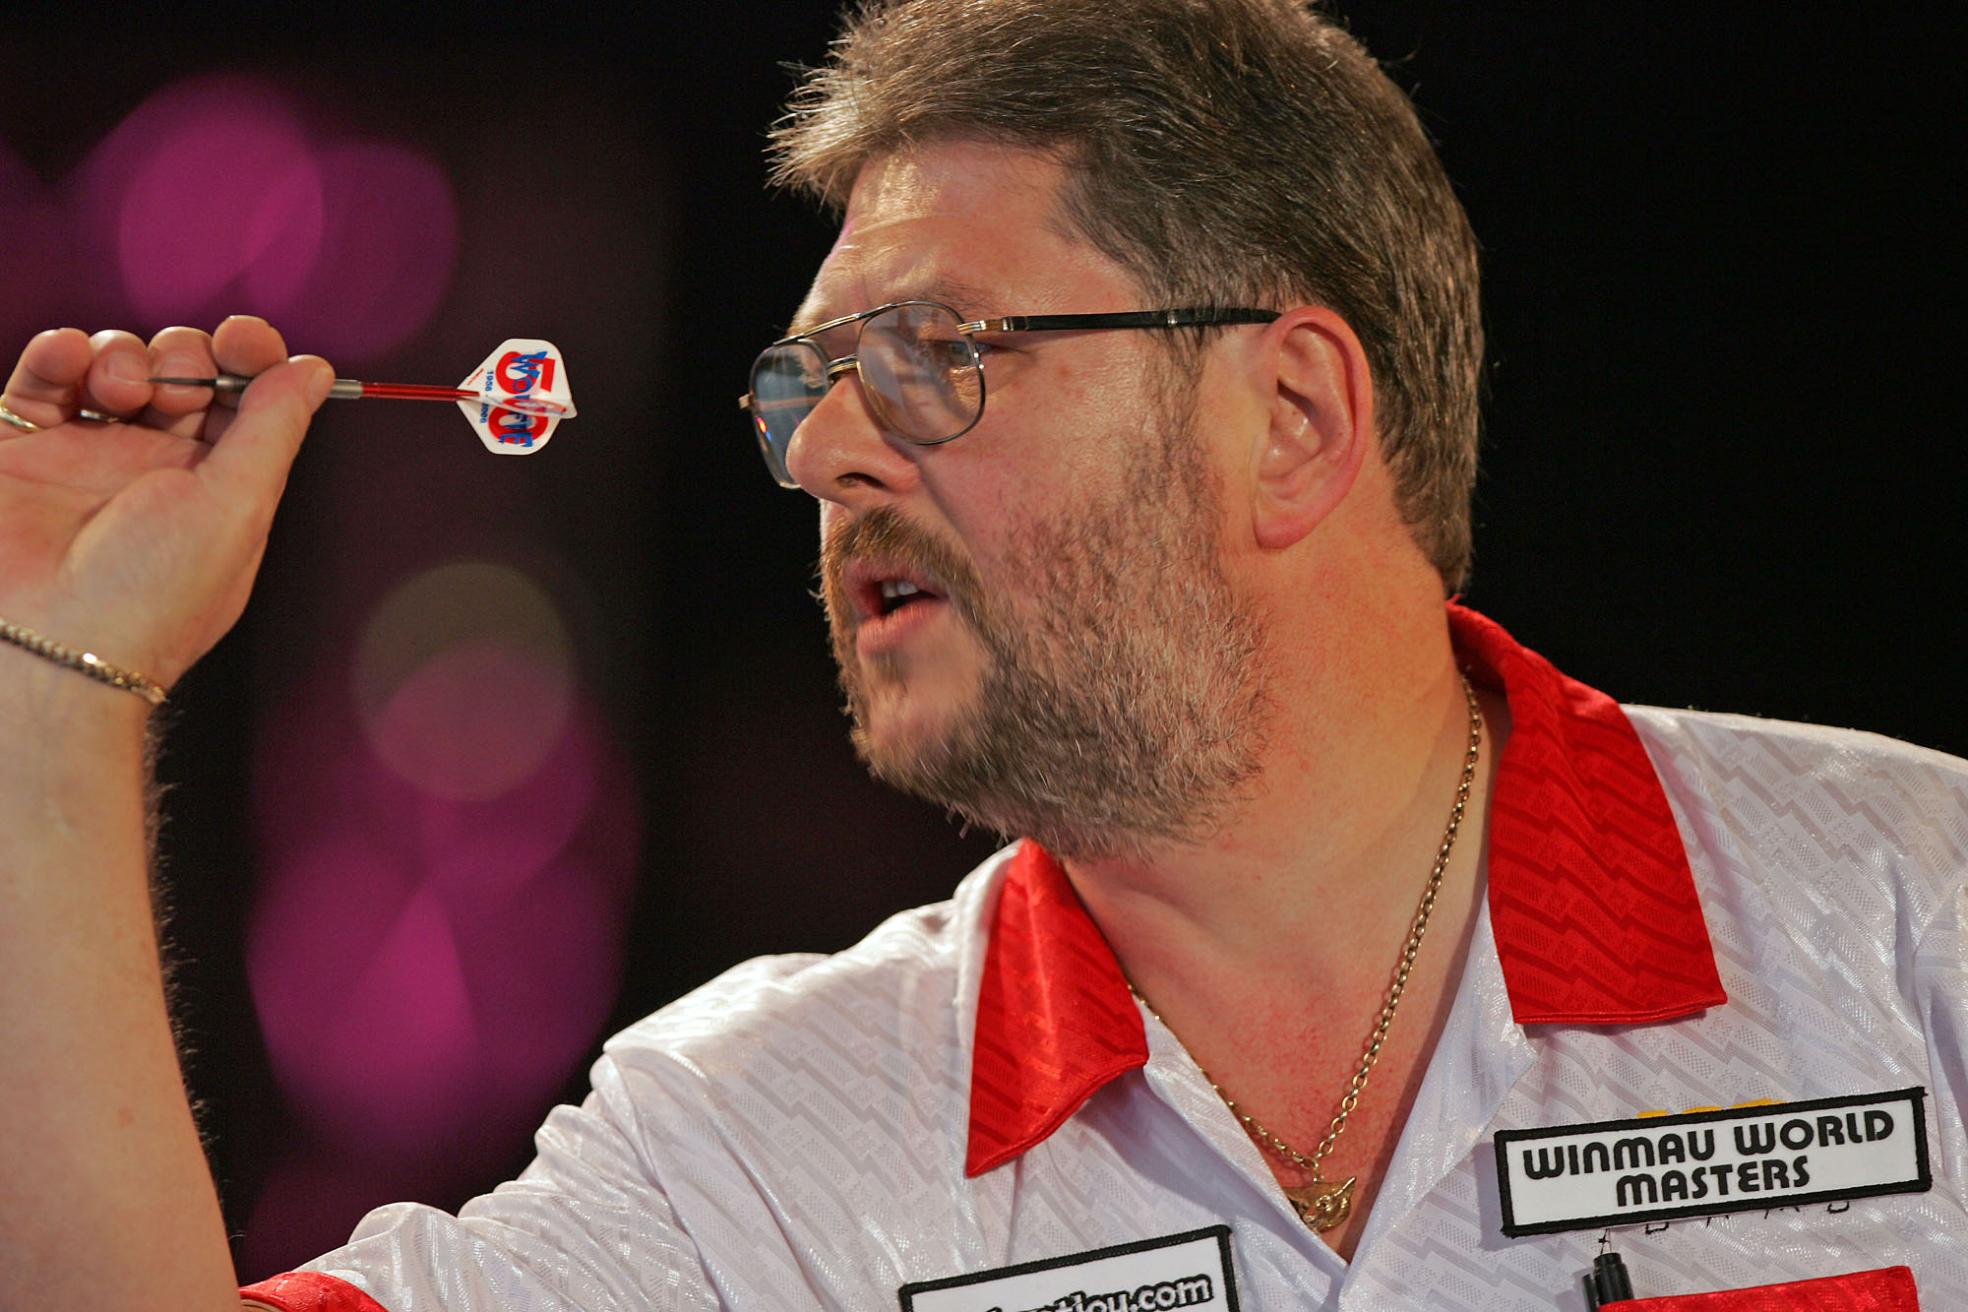
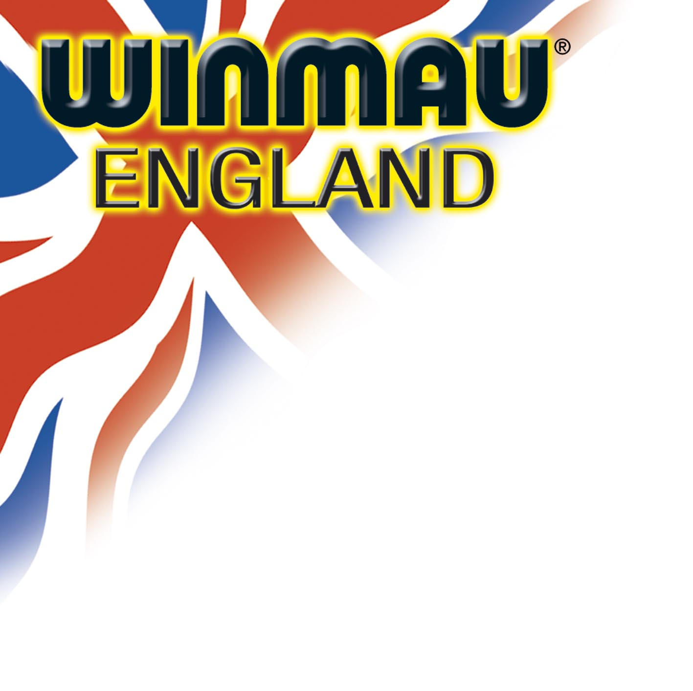
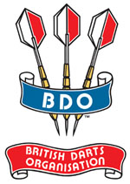

BDO ANNOUNCES NEW LOOK WINMAU WORLD MASTERS

The Board of Directors of the British Darts Organisation have today announced a series of significant enhancements to the 2007 Winmau World Masters, following its annual review of the tournament calendar.

This is integral to the BDO’s policy of continually moving forward to meet the demands and expectations of its players and supporters, as well as its responsibilities to its commercial and broadcasting partners.

To reflect this, the 2007 Winmau World Masters will benefit from:

- The top eight Men’s Seeds competing in the BBC televised stages over the weekend of Saturday, November 17th and Sunday, November 18th.
- A new stage set.
- And a record breaking prize fund of £60,000 – making it the richest two-day televised darts tournament on British terrestrial TV.

More than seven hours of live coverage will be screened on BBC-1 and
BBC-2, and the top ranked eight players in the BDO Invitation tables after the 2007 World Darts Trophy, and available and eligible to compete in the World Masters, are:

No.1 Seed: MARTIN ADAMS
No.2 Seed: TONY O’SHEA
No.3 Seed: GARY ROBSON
No.4 Seed: MARTIN ATKINS
No.5 Seed: TED HANKEY
No.6 Seed: DARRYL FITTON
No.7 Seed: JOHN WALTON
No.8 Seed: CO STOMPE

“These eight seeded players have shown their total commitment to BDO and WDF darts throughout the last 12 months by travelling the world and competing in an average of between eight and ten of the top International and World ranking events”, says Olly Croft, OBE.

“By doing so, they have not only earned their ranking points, but have also secured the right to be recognised as seeded players in the World Masters. This mirrors the way in which our players are recognised in the Lakeside World Professional.

“The Men’s World Professional currently has an invitation criteria that includes 16 Seeds from the BDO International Rankings, the players who finished in the last four in January, the past three World Pro Champions, and players in the ranking table up to the cut-off point. This allows for between 4 or 5 or 6 players to come through the International Play-Offs on Thursday, November 15th at Leisure World, Bridlington.

“In addition to the eight seeded players in the 2007 Men’s World Masters, there will be a further eight available places for the televised stage matches, and the competition to secure these places will come from a true world field. This includes:

- Players from seventy countries have been invited to participate.
- The current Champions from over 150 National and International Singles events.
- The top twenty from the BDO Men’s International Invitation table.
- The top players in the BDO British Grand Prix
- The top players in the BDO Inter-County averages for 2006/2007.
- Qualifiers from the England, Scotland and Wales National play-offs.
- Qualifiers from over twenty worldwide National play-offs.

The Winmau Dartboard Company has introduced JJB Sports to the sponsorship mix, as well as retaining Jackpotjoy.com as shirt patch sponsors for the second successive year.

Together with the generous support of East Riding of Yorkshire Council, this has resulted in a 100% increase in prize money to £60,000 – making the 2007 World Masters the richest two-day televised tournament on British terrestrial television.

“It is an exciting World Masters package that reflects our forward thinking plans for the future of BDO darts and our major Grand Slam tournaments”, adds Olly Croft.

“It is only right and fair that our two major televised World Championships share a criteria that rewards the commitment of the top ranked BDO and WDF players on an annual basis”.

The 2007 Winmau World Masters, in association with JJB Sports and supported by East Riding of Yorkshire Council, is organised and promoted by the British Darts Organisation.

It will be played at Leisure World, Bridlington from November 16th (multi-board matches) to November 17th & 18th (featuring BBC televised stage matches from the Last 16 of the Men’s Masters).

Press Release: Issued Tuesday, October 23rd, 2007

Issued by THE BRITISH DARTS ORGANISATION: 23/10/07

