Mark Webster: Darts hottest young talent joins Winmau
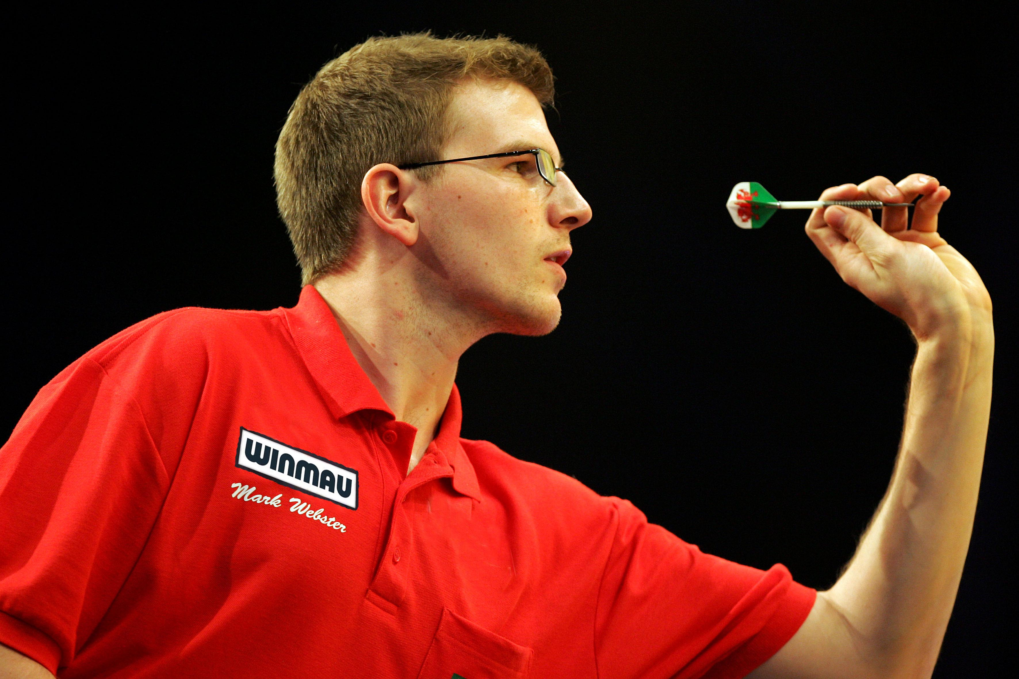

Current World Darts Federation Number 1 ranked player, Mark Webster aged 23 has signed a 3 year sponsorship deal with Winmau.
Mark first started playing darts at the age of 18, and his results demonstrate one of the most promising starts from the latest crop of exciting young darts players. He has won several darts titles, including the European Singles, Northern Ireland Open, Canadian Open, Welsh Masters, and Welsh Open and already has two televised final appearances at the Winmau World Masters and IDL Championship under his belt.
Mark is a passionate, level-headed dart player who has shown through his first years on the World Darts Circuit that he can stand up to the toughest situations both on and off the Oche without losing his head.
Mark said “I am really excited to be joining Winmau. It is such a legendary company, you can't escape the history and reputation they have in World Darts and I’m really looking forward to being part of the Winmau Team”.
Mark will join Winmau’s 10 times World Champion teammates Andy Fordham, Dennis Priestley and Trina Gulliver, and all agree that Mark has the skill, temperament and passion to become one of the greatest dart players in the world.
For further information log on to www.winmau.com, email info@winmau.com or call +44 (0)1656 767042

